Phase 1

Mobile App Requirements

Remote Patient Monitoring

Version | Date | Updated by | Changes
1.0 | 05/09/2022 | Bindu.K | Mobile App requirements for Phase 1 release.  Features marked in Blue will be part of Phase 2.
Amendment History

Project Overview

Remote Patient Monitoring (RPM) is the use of digital technologies to monitor and capture medical and other health data from patients and electronically transmit this information to healthcare providers for assessment and, when necessary, recommendations and instructions.

Through the use of innovative technologies and open platforms, this project is to design & develop an Online Platform (Web Portal & Mobile Application) to Register, Monitor and Analyze health data of patients remotely for the healthcare support. This tool also helps the Insurance providers to analyze health data of their customers
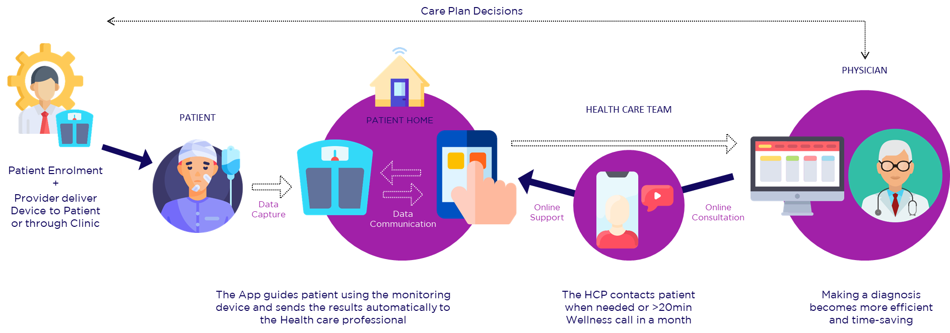

Requirements Overview
Patients enrolled in RPM program are provided RPM mobile app for patient communications and vital monitoring. When a patient enrols into a program, patient user id will be created. Login credentials and app link will be shared with the patient via SMS. Mobile Application will be available in Android and iOS platforms (mobile and tab view )for the users to download it.
Remote Patient Monitoring uses Blue tooth and LTE enabled medical devices to send the patient vital data. For blue tooth devices, vital data will be collected through mobile app and send to Cloud storage.

Application Features

User login
Patients can login to the app using Patient id and password shared by the RPM provider. For multi factor authentication, OTP will be sent as SMS to allow app access for more security.
App should validate invalid logins and provide appropriate error messages. Multiple sessions/multiple logins with same user id should not be allowed. In such cases, other sessions can be killed. Once patient has logged in, session should not be timed out until the user logs out (in case of single sessions).

Forgot Password
Patient can reset the password using Forgot password. Moved to phase 2.

Home page
Home page should contain the following details for the patient and program.
- Patient Name,Patient ID,Patient Status
- Latest Care Plan Name and Status
- Chat feature to initiate chat with the designated Care team member - Moved to Phase 2
- Call feature to call the designated Care team member – Moved to Phase 2

- Notifications –All notifications (read + unread ) will be listed in this page with Unread count. Unread messages can be highlighted. Notification should open in a separate window on clicking it and can be mark as ‘Read’ .
Read all – Can be used to mark all the unread notifications as ‘Read’.
Notifications can be deleted using hard press or delete option. (To be included in UI design, this is not available currently and to be developed for Phase 1)
This list can be capped to current programs duration .
Note : Follow the features similar to Phone SMS or App Notifications .

- TODO list – To do activities for the day. This will include Vital schedule, Patient Schedules, medication reminders set by the care team member.
- Recent Vitals and Charts – Last vital reading and 7 days reading chart for the vital measurement should be displayed. Highlight vitals based on their Critical,Cautious and Normal Status. Vitals associated to patients’ current program only should be displayed here.

TODO List
- View of TODO list for the current program.
- Default list will be current days list of Activities (Vital schedules/Wellness calls/Medication reminders)
- User can see the activities of current week on date selection.
- Week can be scrolled back and forth to select the dates.
- User can use arrows to see todays, tomorrows, yesterdays and so on. (this feature is to support patients who don’t remember/follow dates.follow the standard display to label Last week,Next week ,Today etc)
- Dates selectable should be in the range of current program duration.
- TODO activity will open in a separate window on selection of an activity.
- Add/Edit/Delete features will be part of Phase 2.

Vitals
- Vital readings for the current day are displayed by default.
- Critical and Cautious vitals should be highlighted in colours provided in UI design.
- Use arrow key to see the past vital readings.
- In Tab view, user can select the past dates from the Week display. Weeks can be scrolled back using arrow key.
- Dates selectable should be in the range of current program duration.
- Vitals associated to patients’ current program only should be displayed here.
- View more Option is moved to Phase 2.

Health Trends
- Vital reading chart can be viewed in this page.
- By default, Todays chart will be displayed for the vitals measurements.
- Critical and Cautious vitals should be highlighted in colours as in UI design.
- Dates selectable should be in the range of current program duration.
- Vitals associated to patients’ current program only should be displayed here.
- User has option to view the health status on selection of Today, Last 7 days and 30 days period.
- Today – Only todays vital reading should be displayed based on time.
- 7 days - Last 7 days, day wise reading should be displayed
- 30 days - Last 30 days, day wise reading should be displayed.
- All – To be decided if this can be displayed as day wise.

Account
- Patient name and Patient id should be displayed here
- My Info – Personal, Communication and Preference details can be viewed here. Only view option is available. Patient has to contact care team member for any information updates.
- Change Password - Patient can change the password using change password screen. Current password to be entered and validated first to enter the new password. Password policy to be followed for New password and Confirm password. Once password is changed user session to be logged out automatically and redirected to the login page. If sessions are active in Web login for the same user , this needs to be logged out automatically.

